# **Web Development Module (JQuery Basic, Effects & Advanced) - 5**

**Q1: What is jQuery?**

**Ans**: jQuery is a fast, lightweight, and feature-rich JavaScript library designed to simplify client-side scripting of HTML. It aims to make things like HTML document traversal and manipulation, event handling, and animation much simpler with an easy-to-use API that works across different browsers.

The primary purpose of jQuery is to provide a more concise and efficient way to interact with HTML elements and manipulate the DOM (Document Object Model). It abstracts many complex functionalities in JavaScript, making it easier for developers to write powerful, cross-browser compatible code.

jQuery simplifies common tasks like:

1. DOM manipulation: Selecting and manipulating HTML elements.
2. Event handling: Managing events and actions on a web page.
3. AJAX requests: Making asynchronous requests to the server.
4. Animations: Creating smooth animations and effects on web pages.
5. Utilities: Providing utility functions and methods to perform various tasks.

By using jQuery, developers can write shorter, more readable code, and it helps in achieving consistent behavior across different web browsers. However, as of my last update in January 2022, modern JavaScript and web standards have evolved significantly, and some of the functionalities provided by jQuery can be accomplished directly using native JavaScript or through newer frameworks and libraries. It's essential to weigh the pros and cons of using jQuery in current web development, considering factors such as performance, browser support, and the specific needs of a project.

**Q2: How to Apply CSS jQuery, How to Add Class and Remove Class in jQuery, jQuery Animation?**

**Ans:** To apply CSS using jQuery, add or remove classes, and perform animations, you can use jQuery methods to manipulate elements on the page. Here's a basic overview of how you can achieve these tasks:

**Applying CSS with jQuery:**

1. Applying CSS directly:

You can use the `css()` function to directly apply CSS styles to elements selected by jQuery selectors.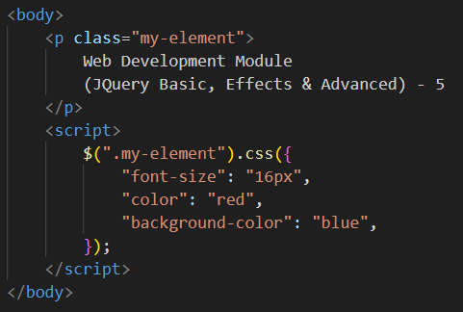

2. Adding or removing classes:

Adding a class:



Removing a class:



**jQuery Animation:**

jQuery provides functions for animating elements on a webpage. Some common animation methods are:

1. `slideDown()`, `slideUp()`, and `slideToggle()` for sliding an element up or down.

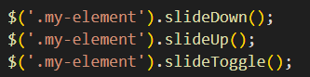

2. `fadeIn()`, `fadeOut()`, and `fadeToggle()` for fading an element in or out.

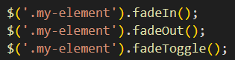

3. `animate()` for custom animations (e.g., moving an element, changing its size).

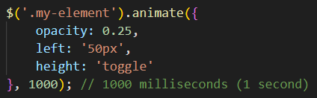

These are just a few examples of how you can use jQuery for adding or removing classes, applying CSS, and performing animations. The key is to select elements using jQuery selectors and then use the appropriate functions to manipulate them according to your requirements.

Remember, it's crucial to have a solid understanding of jQuery selectors and syntax to effectively apply these methods for your assignment. Also, in modern web development, CSS animations and transitions or using newer JavaScript frameworks might be preferred over jQuery for animations due to performance reasons.

**Q3: How to create slider whit animation?**

**Ans:**

**HTML,**

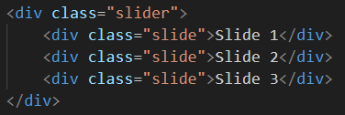

**CSS,**

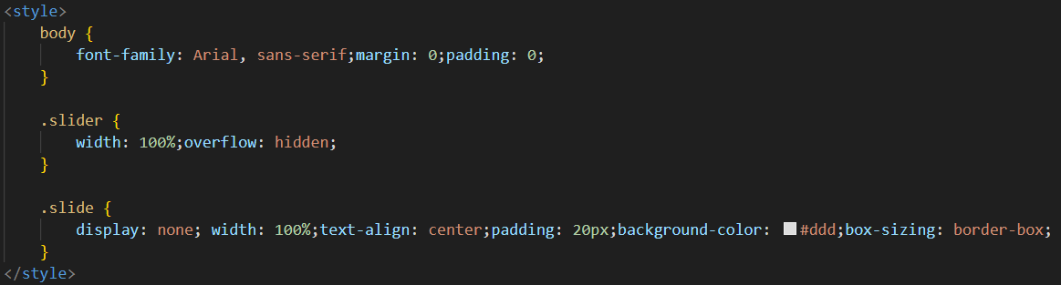

**SCRIPT,**

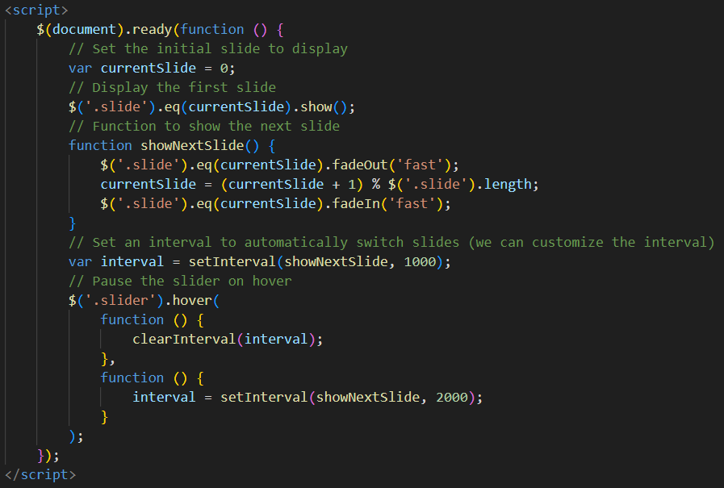

**Q4: Event bubbling tickling example**

**Ans:**

**HTML,**

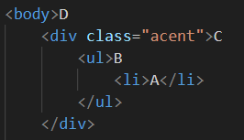

**CSS,**

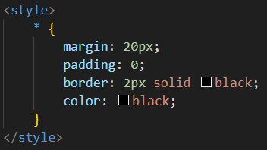

**jQuery,**

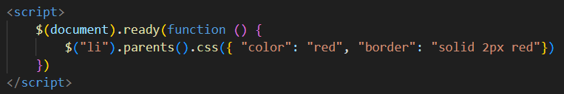

**Output,**

